Laboratory Equipment
Beaker | 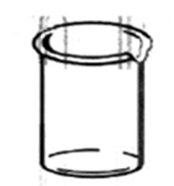 | common sizes include: 50 ml, 100 ml, 250 ml, 400 ml  LEAST accurate in measuring volume
Beaker tongs | 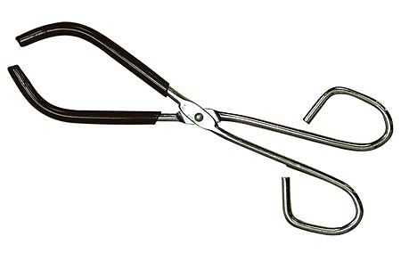 | used to transfer hot beakers
Buchner funnel | 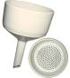 | filters solids from liquids using a mild vacuum
Bunsen Burner | 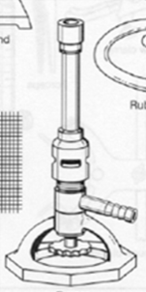 | source of heat/flame using gas
Buret | 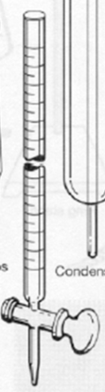 | used to measure volumes of solution during titrations (vertical image is tilted horizontally in this illustration)
Crucible & cover | 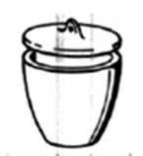 | porcelain, used to heat small amounts of substances at high temperature
Crucible tongs | 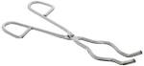 | iron/nickel, used to pick up & hold small items
Digital balance | 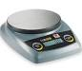 | scale used to measure mass
Double buret clamp | 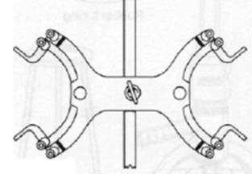 | holds burets in place when titrating
Erlenmeyer flask | 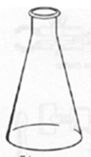 | used to mix a liquids by swirling contents
Evaporating dish | 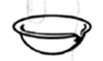 | porcelain, used to hold small volumes of liquid to be evaporated
Filter paper |  | used to separate solids from liquids
Filtering flask | 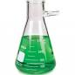 | used with a Buchner funnel and a water aspirator
Forceps |  | used to pick up small objects
Funnel | 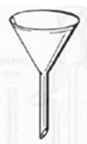 | glass or plastic, often used with filter paper
Gloves | 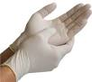 | protect skin from harmful chemicals
Graduated cylinder | 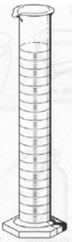 | used to measure approximate volumes (ml)  more accurate than a beaker
Graduated pipet |  | measure solution volumes  less accurate than volumetric pipet
Hot plate/stirrer | 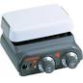 | mechanically mixes solutions while heating
Mortar and pestle | 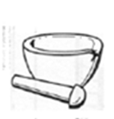 | porcelain, used to grind crystals or lumpy chemicals into powder
Petri dish | 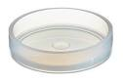 | used to hold materials
Pipe-stem triangle | 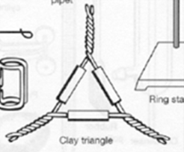 | holds crucible and lid in a flame
Pipetter | 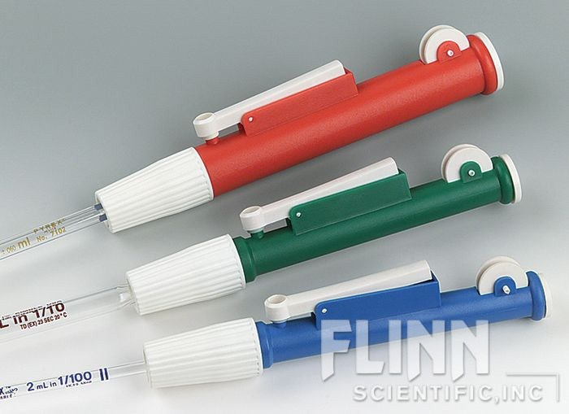 | used to accurately draw up liquid into pipet
Ring clamp | 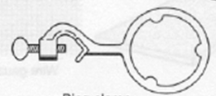 | used with wire gaze to support a beaker when heating over a flame
Ring stand |  | used as a support for lab equipment
Rubber stoppers | 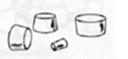 | used to stopper flasks and test tubes
Rubber tubing | 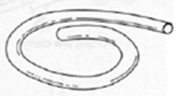 | apparatus to transfer liquid or gas
Safety goggles | 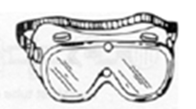 | eye protection
Scoopula |  | used to transfer solid chemicals from stock
Stirring rod |  | glass or wood, used for mixing
Test tube brush |  | cleans a test tube
Test tube holder | 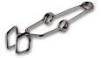 | holds a single test tube
Test tube rack | 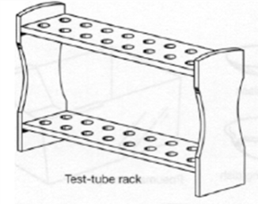 | holds test tubes
Test tubes | 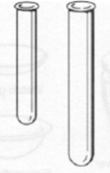 | mix small quantities of liquids and solids
Thermometer | 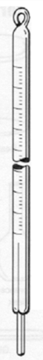 | measures temperature  common range –10ºC to 110ºC
Volumetric pipet |  | most accurate in measuring volume
Wash bottle, plastic | 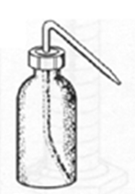 | contains distilled water, used for rinsing
Watch glass | 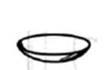 | used to cover an evaporating dish or beaker
Well plate  (Spot plate) | 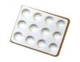 | surface used to react small amounts of chemicals
Wire gauze |  | used with ring clamp to support a beaker when heating over a flame

